Course Name

July 25, 2025

Table of Contents

# About

What is the essence/purpose of this course or module (2-3 sentences).



Figure 0.1: C-MOOR logo

### Audience and Prerequisites

What is the target audience?

**Prerequisites**:

* Prereq 1
* Prereq 2

Why are these needed? Provide a brief explanation that will help instructors decide whether it’s a good fit for their students.

### Format

* **Class Type:**
* **Lesson Length:**

### Learning Goals

1. Goal 1
2. Goal 2
3. Goal 3

### Core Competencies

This activity addresses the following core concepts and competencies:

**Vision and Change**

**Genetics**

**Bioinformatics**

Core concepts and competencies are taken from the following sources:

* [Vision and Change in Undergraduate Biology Education](https://visionandchange.org/) AAAS report
* [Genetics Core Competencies](https://genetics-gsa.org/education/genetics-learning-framework/) by [GSA](https://genetics-gsa.org/)
* [Bioinformatics core competencies for undergraduate life sciences education](https://doi.org/10.1371/journal.pone.0196878) by [NIBLSE](https://qubeshub.org/community/groups/niblse)

### C-MOOR Content Collection

This content is part of a collection of teaching resources developed by C-MOOR. C-MOOR works to break down barriers to scientific participation and build pathways for the next generation of data scientists through authentic research experiences. Learn more about C-MOOR by [viewing our projects](https://github.com/c-moor), or read about how C-MOOR is [integrating research experience into undergraduate biology courses](https://www.cloviscollege.edu/alumni-and-community/c-moor/c-moor.html) at Clovis Community College.

# 1 C-MOOR Overview

### 1.0.1 About C-MOOR

C-MOOR is a project to invite students to join the data science revolution and be part of the next generation of data scientists. This project provides online materials to help students and instructors incorporate authentic research experiences in lower division courses.

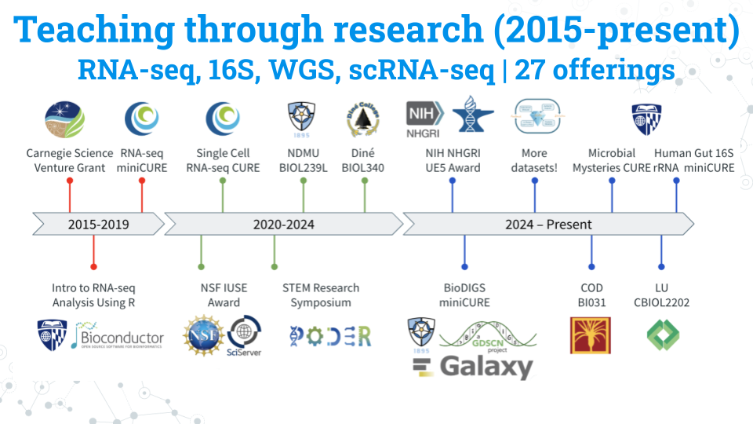

Over the years, C-MOOR has expanded its curricula to include RNA-seq, scRNA-seq, 16S amplicon sequencing, and WGS modules. Here’s some statistics about C-MOOR students:

* **Students taught:** 700+.
* **90% of our students are first years:** We break the myth that only advanced-level students can perform and excel in real research.
* **Student research posters:** 100+. We choose a poster as our final deliverable to facilitate participation in research symposiums. Posters also allow us to evaluate the efficacy of our curricula over the years and make it easy for instructors to quickly and objectively grade student work. You can see a handful of posters [here](https://help.c-moor.org/c/look-at-this/8)!
* **50% + Students choose to present posters at optional symposiums:** C-MOOR posters have served as the impetus for establishing a new research symposium at Clovis Community College. Our students have attended and won awards at their institution’s research days and at conferences such as GRADS-4C and the ASM Maryland Branch Meeting.

### 1.0.2 Why data science?

Data Science is an evolving career path for individuals (data scientists) in fields that need to manipulate large amounts of data. The job of a Data Scientist was called by the Harvard Business Review “[the sexiest job of the 21st century](https://hbr.org/2012/10/data-scientist-the-sexiest-job-of-the-21st-century)” Data Scientists are individuals with a curiosity to look through data, identify patterns and develop testable hypotheses. In the Biological Sciences, data scientists dig through data to answer questions about health, disease, evolution, ecology, drug development, and much more. A currently relevant example is compiling and looking at the similarities and differences between the different SARS-CoV-2 strains and identify differences between strains that may lead to differences in rates of infection.

### 1.0.3 Learning Goals

1. Engage with real and current scientific data
2. Explore available research resources online
3. Recognize the interdisciplinary nature of biological sciences
4. Synthesize findings from scientific literature
5. Summarize findings and discuss results with your peers
6. Collaborate with peers on a data exploration activity

# 2 For new instructors

Welcome to new and seasoned instructors alike! We are excited to have you use a C-MOOR module in your class. This section of our OTTR book is specifically for instructors and will help you prepare for teaching a C-MOOR offering as a part of your class.

### 2.0.1 Course-based undergraduate research experiences

A **course-based undergraduate research experience (CURE)** is a high impact practice (HIP) where students learn through authentic research. In addition to the standard concepts of the material and the technical skills required to complete lab exercises students gain critical thinking skills troubleshooting their research projects. They don’t just learn about science; they practice it!

### 2.0.2 How C-MOOR supports you

Our curriculum is designed to be accessible for anyone to teach and aims to remove many of the barriers that prevent instructors from trying computational biology methods.

* **No previous experience in bioinformatics required. We’ll help with the code:** We provide all code templates required to complete the analyses. You just bring your expertise as a researcher! For support with code and other technical issues reach out to us with a post on the [C-MOOR Academy Discussion Forum](https://help.c-moor.org/). Someone will assist you as soon as you are available.
* **Our curriculum comes with lectures, assignments, and rubrics for you to use**: We do as much as possible to take the workload of creating these materials off your back. But you’re not beholden to use them; if you have materials you’ve used over the years and prefer to use or want to use only parts of ours you’re free to do so.
* **We designed our miniCUREs to be modular to fit into your course**: Our miniCURE curricula are designed to be compact, with just 6 main sessions followed by project work. We’ve taught our RNA-seq miniCURE in pre-established classes, such as introductory biology. You don’t have to design your entire course around them and the modules fit easily into your lessons about gene expression and microbiology.

### 2.0.3 New instructor to-do list

If you haven’t taught a C-MOOR curriculum in the past, here’s a list of tasks you should do, ideally before the semester begins:

1. **Make an introductory post on the** [**C-MOOR Academy Discussion Forum**](https://help.c-moor.org/) in the general category. We recommend including:

* Your name
* Your institution
* The class you’re teaching that uses C-MOOR modules
* Your area of research expertise
* Any previous experience with bioinformatics
* The cloud platform you will be using to teach (see next item)

1. **Set up on a cloud platform**: C-MOOR uses either [SciServer](https://www.sciserver.org/) or [AnVIL](https://anvil.terra.bio/) for our cloud computing needs. If you’re not sure which is right for you, please mention this in your forum post so we can get you set up on whichever is more appropriate. Once you’ve chosen your cloud platform, follow the instructions in the respective section to access modules and learn how to grant your students the same access. While you can technically run the modules locally, running them on a cloud platform will prevent the need for students to download all the neccessary components and provides you easier access to updates.
2. **Go through the modules yourself**: Familiarize yourself the curriculum and how to use the cloud platform and our fill-in-the-blank code chunks. Look through our resources and see what support is currently available; for example, our [C-MOOR RNA-seq guide](https://docs.google.com/presentation/d/1ic09dhbt6WLEAgBTOqfT_tveknFF936BPVC2JhjutmY/edit?usp=sharing) and our student made [How To Get Started With Your C-MOOR Project Guide](https://docs.google.com/document/d/1WxlN2XG5_VEDN0u-JpAO7dJQrG8P0YG6Svm-eEvagxY/edit?usp=sharing).
3. **Look over our generic** [**C-MOOR Poster Rubric**](https://docs.google.com/document/d/1Aq4wVqO6S-PbKuV-rBiiRySVor_FLaRHp_CPuWBJPm4/edit?usp=sharing) and alter it as neccessary. The rubric is designed so that you can choose what sections you want included in your students’ posters and what weight (point values) you want to give to each element. Students will use the rubric as a checklist as they create their posters. Some instructors share this rubric at the start of their class. Others may leave it until later. If you have a specific symposium or conference in mind, tailor the rubric to suit that venue (ex. if your school’s research day requires posters with abstracts and no introductions, change the rubric to reflect this requirement).
4. **Consider your syllabus and where each module fits into your class schedule.** We provide estimated times for each module and the activities within as well as sample schedules from instructors who have taught the curriculum before. Some instructors teach a wet lab alongside the C-MOOR curriculum, using downtime (ex. waiting for the results of a gel electrophoresis lab) to do computational activities.
5. **Have students create an account on your chosen cloud platform and provide the neccessary information to you:** Do this well in advance of the first day you’re using the C-MOOR curriculum to avoid technical issues on the day of (ex. students without Google associated email addresses on AnVIL, students who have unknown errors logging into SciServer). You will need to collect the students’ email addresses (AnVIL) or their usernames (SciServer). We recommend using tools in your LMS or a Google form to expedite this process.

# 3 Cloud platforms

Although you can technically run C-MOOR modules locally, we strongly recommend you use a cloud platform. The benefits of using the cloud platform:

1. Students do not have to go through a lengthy and complicated download and installation process
2. Students will use identical containers (computational environments) on the cloud environment, which prevents troubleshooting that might occur from differences in individual computers
3. It’s far easier to keep with the most current version of our curriculum on a cloud platform that it does on local laptops; every time you load a container on the cloud any new updates will be pulled directly from our GitHub.

We have two different cloud platforms on which to run our modules, **SciServer** and **AnVIL**. Your choice will depend on a number of factors, such as the budget for your course and whether you will work with restricted-access datasets.

At this time, we are still piloting our modules on AnVIL. New instructors should read out to us as the [C-MOOR Academy Discussion Forum](https://help.c-moor.org/c/help/) to determine which cloud platform is more appropriate for you and help get you access to our materials.

# 4 SciServer

## 4.1 About SciServer

SciServer is an online platform for doing scientific data analysis. It is used by scientists studying astronomy, biology, oceanography, and more, and is free as long as you are using it for scientific research. Using SciServer means you do not need a fancy computer or need to install any special programs on your computer, you can just log in with your internet browser to start doing research. For this course, we have set up SciServer with customized collections of programs for RNA-seq analysis, as well as the data that we’ll be analyzing. Once you sign up for SciServer and are added to the group for this course, you will be able to access these tools and begin your data analysis journey!

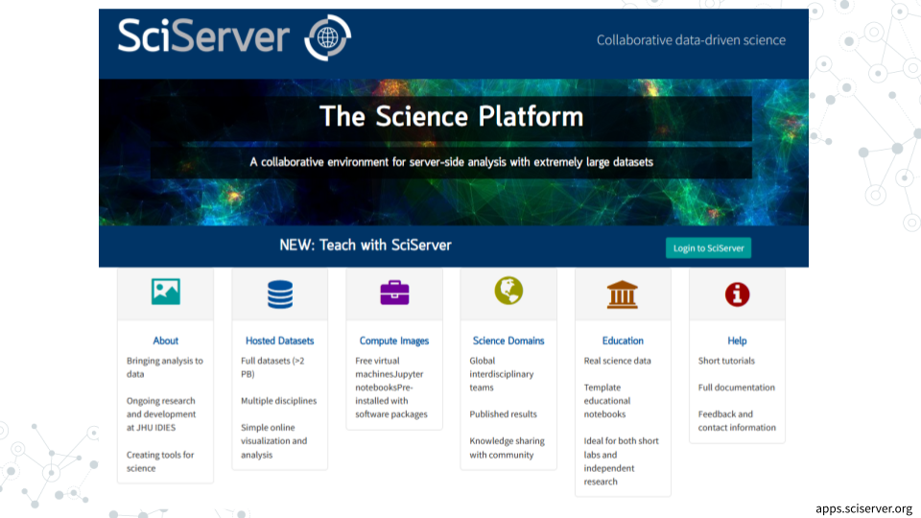

## 4.2 Setup your SciServer account

#### 4.2.0.1 Purpose

Students will create a SciServer account and be added to a SciServer by their instructor, which gives them access to the images and data needed to access learning modules and complete their research project. **The steps in this section only need to be completed once.**

#### 4.2.0.2 Learning Objectives

1. Create an account on SciServer
2. Confirm your email address
3. Share your username with your instructor
4. Confirm your access to class materials on SciServer

This video ([video](https://link.c-moor.org/video-join-sciserver))([slides](https://docs.google.com/presentation/d/1kxbnBLoRsdPW4ZkjwNsAHS1XFPuJpQZ8I1aVqyZISW0)) shows you how to create a SciServer account. You can follow along with the video, or follow the steps below.

### 4.2.1 Create a SciServer account

1. Open [sciserver.org](https://www.sciserver.org/) in a web browser
   1. It is a good idea to bookmark this page so that you can easily access it throughout the course.
2. Click “Login to SciServer”
3. Click “Create a new account”
4. Enter a User name, Email, etc. and click “Create account”
   1. Note that you cannot change your username once you have made your account

### 4.2.2 Confirm your email address

1. **Important!**: Click the verification link in your email inbox.
   1. If you do not verify your account you will get locked out and will need to contact your instructor to unlock your account.
   2. If you do not see an email, try checking your spam folder.
2. After clicking the verification link, confirm that your username appears in the upper right hand corner.

### 4.2.3 Share your username with your instructor

Refer to your instructor on how to share your username with them. Your instructor will add you to a group that will give you access to all the necessary resources.

1. Share your username with you instructor and await invitation to the SciServer group

### 4.2.4 Accept the invitation to join a SciServer group

This video ([video](https://link.c-moor.org/video-join-sciserver-group))([slides](https://docs.google.com/presentation/d/1codot9UeUO7l0EDcEre7dJgyXurD_xyxpw6IJL_aEjM)) shows you how to join a SciServer group. You can follow along with the video, or follow the steps below.

1. Open [sciserver.org](https://www.sciserver.org/) in a web browser and log in to your account.
2. Click “Groups”
3. On the left, you should see a list of all the groups you have joined or been invited to. Click on the name of the group for this course, then click “Accept invitation”.
   1. Your instructor must have your username to invite you to the group. If you do not see an invitation, contact your instructor with your SciServer username.
4. Confirm that you can access course data
   1. On the top menu bar, click “Files”
   2. On the left-hand menu, click “Data Volumes”
   3. Confirm that you see “C-MOOR-Data”
5. Confirm that you can access course computing resources
   1. Click “Home” in the top menu to return to the home page.
   2. Scroll down to the second set of boxes and click “Compute”
   3. Click “Create container”
   4. In the “Compute Image” drop-down menu, confirm that you can see “C-MOOR LearnR” and “C-MOOR R-Studio”
   5. Under “Data Volumes”, confirm that you can see “C-MOOR Data”
   6. You can close the Create Container dialog box (by clicking the “X” in the top right) once you’ve confirmed that you can see the C-MOOR content

#### 4.2.4.1 Troubleshooting

* Some students have had issues signing up or logging into SciServer but were successful at a later date/time. We suggest giving students time to sign up well in advance of their first module on SciServer in case of technical difficulties.

## 4.3 Running modules on SciServer

#### 4.3.0.1 Purpose

The purpose of this assignment is to learn how to access the modules for your course on SciServer and properly close out your session when finished.

#### 4.3.0.2 Learning Objectives

1. Start up a C-MOOR LearnR compute container
2. Access a C-MOOR module
3. Delete your C-MOOR LearnR compute container when finished

Before beginning this assignment, you should have already created a SciServer account and submitted your SciServer username to your instructor. In this assignment you will learn how to set up a “compute container” on SciServer. Compute containers are how you use programs on SciServer. There are two C-MOOR compute containers on SciServer: “C-MOOR LearnR” has tutorials that will teach you how to run data analyses, and “C-MOOR R-Studio” is where you can work on your own data analysis projects. This assignment shows you how to set up the C-MOOR LearnR compute container and start up your first tutorial.

### 4.3.1 Start up a “C-MOOR LearnR” compute container

This video ([video](https://link.c-moor.org/video-sciserver-create-learnr-container))([slides](https://docs.google.com/presentation/d/1Oaq8RzhaDANxkNh-tTKwme7e095pGgoiq5iZHbt7PLg)) shows you how to create and start up a C-MOOR LearnR compute container. You can follow along with the video, or follow the steps below.

1. Open [sciserver.org](https://www.sciserver.org/) in a web browser and log in to your account.
   1. If you are already logged in, click “Home” in the top menu to return to the home page.
2. Scroll down to the second set of boxes and click “Compute”
3. Click “Create container”
   1. Give your container a name. This can be anything you like, but it’s useful if it says something about the purpose of the container so you can tell your containers apart. You could name this container “Tutorials”, since you’ll be using it to access tutorials.
   2. In the “**Compute Image**” drop-down menu, select the **C-MOOR LearnR that your instructor chooses**
   3. Under “**Data Volumes**”, check the box next to “**C-MOOR Data**”
   4. Click “Create”. This may take a moment.
4. You should now see a new entry in your list of containers
   1. “Created At” should be a few moments ago.
   2. “Name” should be the name you chose
   3. “Image” should be “C-MOOR LearnR”
5. Start your C-MOOR LearnR container by clicking on its name (whatever name you chose when you created it). This will open in a new tab.
   1. You should see a list of tutorials, organized by topic.

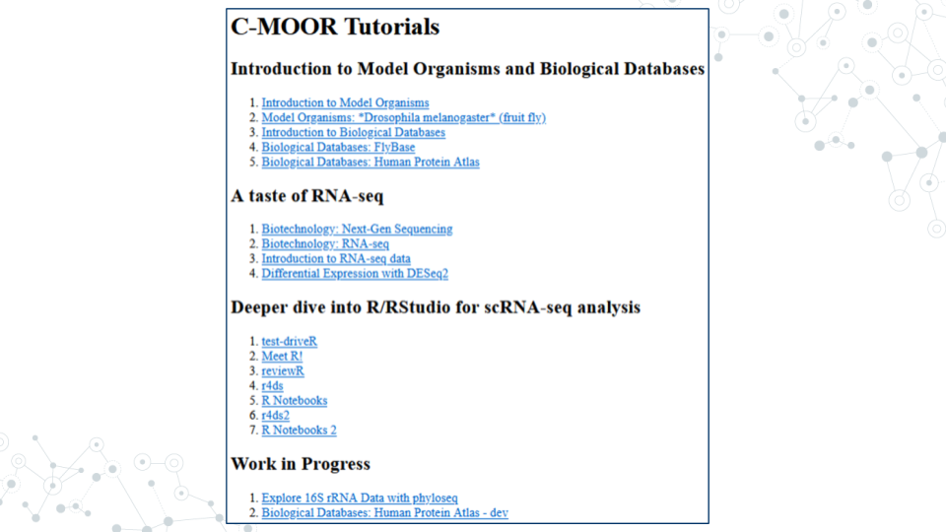

1. If instead you see an error message, you most likely forgot to check the box next to “C-MOOR Data” when you created the container.

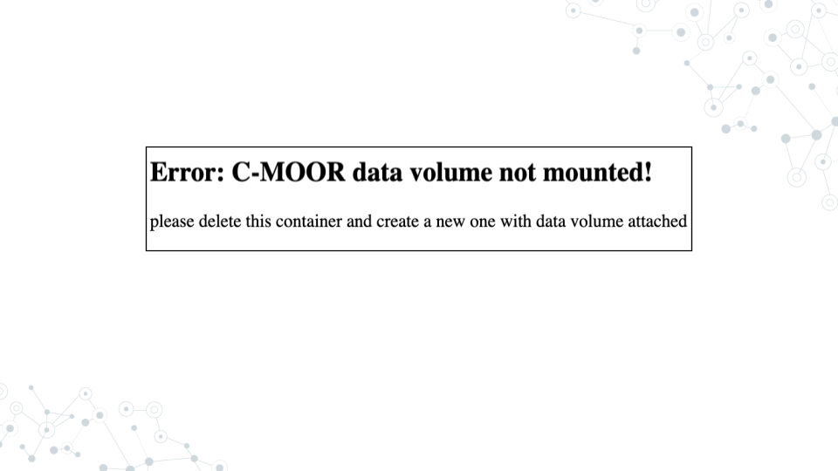

1. If you see something else, you may have picked the wrong “Compute Image” from the drop-down menu.

**If anything goes wrong, you can always delete your container by clicking the red “X” in the last column, and create a new container.**

### 4.3.2 Opening C-MOOR modules

1. If you’re not there already, go to the SciServer compute page and start up the C-MOOR LearnR container.
   1. Open [sciserver.org](https://www.sciserver.org/) in a web browser and log in to your account.
   2. If you are already logged in, click “Home” in the top menu to return to the home page.
   3. Scroll down to the second set of boxes and click “Compute”.
   4. Start your C-MOOR LearnR container by clicking on its name.
2. Click on the module chosen by your instructor. The tutorial will open in a new tab.
3. Complete the tutorial.

### 4.3.3 Delete your C-MOOR LearnR compute container

Compute containers are meant to be temporary, and you can only have 3 containers total on SciServer. So it’s generally a good idea to clean up after yourself and delete your containers when you’re done using them. Also, if any updates are made to the C-MOOR LearnR container, **you will need to create a new container to get the latest updates.**

**Deleting your container will delete your progress in a tutorial**, so don’t delete the container until you have completed the tutorial and submitted any required items to your instructor.

To delete a container:

1. If you’re not there already, go to the SciServer compute page.
   1. Open [sciserver.org](https://www.sciserver.org/) in a web browser and log in to your account.
   2. If you are already logged in, click “Home” in the top menu to return to the home page.
   3. Scroll down to the second set of boxes and click “Compute”.
2. Find the container you want to delete.
3. Click on the red “X” in the last column.

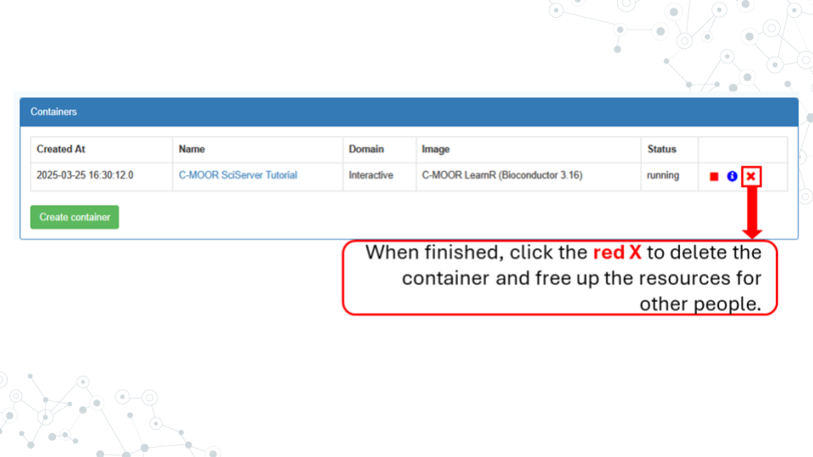

# 5 AnVIL

## 5.1 About AnVIL

AnVIL (The Genomic Data Science **An**alysis, **V**isualization, and **I**nformatics **L**ab-space) is a platform created by the National Human Genome Research Institute (NHGRI) in collaboration with cloud computing platform providers like Google and Microsoft. Using AnVIL we you can access computing resources on the cloud through your browser without need for any fancy physical equipment. Through AnVIL you will also have access to all the software and data necessary to complete your research project.

In this section, we will set up our accounts on AnVIL and go through the entire lifecycle of an RStudio environment from creation to deletion. You will repeat this process throughout the semester; feel free to refer back to this section if you need a refresher on how to use AnVIL.

## 5.2 Sign up for an AnVIL account

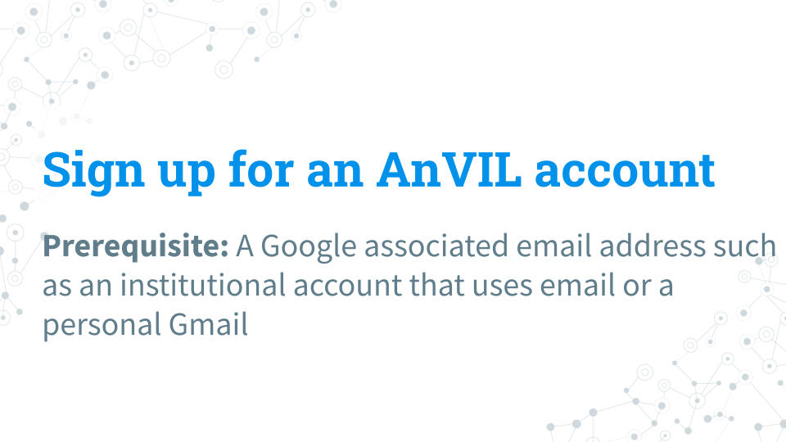

#### 5.2.0.1 Purpose

You will need an account on AnVIL in order to use the platform. In this section we’ll go over the specifics of account creation.

#### 5.2.0.2 Learning Objectives

1. Create an account on AnVIL
2. Login to AnVIL
3. Share the email you used to sign up for AnVIL with your instructor (if applicable)

### 5.2.1 Create an AnVIL account

Follow the written steps below or refer to the [slides](https://docs.google.com/presentation/d/1uwlG7uaTOnItdpd4Ll6nNQiBJKBivsvR-erupicAwJM/edit?usp=sharing) or video guide.

1. Open [anvil.terra.bio](https://anvil.terra.bio/) in **Google Chrome** . Google Chrome is the only officially supported web browser for AnIVL. Because of this, while you can run AnVIL in other browsers you strongly suggest using Chrome.
   1. It is a good idea to bookmark this page so that you can easily access it throughout the course.
2. Click the hamburger icon (3 lines) in the top left corner of the screen
3. Click “Sign in”
4. Click “Sign in with Google”.
5. Sign in with a **Google associated email address** such as an institutional email that uses Gmail or a personal Gmail account. You must use a Google associated email address to gain access to Google Cloud computing resources.
6. If you are a student, share the email you used to sign up for AnVIL with your instructor following their instructions. If you are an instructor on a C-MOOR billing project, share the email you used to sign up with someone from C-MOOR.

**Until your account is associated with a billing project you will be unable to use computational resources on AnVIL.**

## 5.3 Set up billing in AnVIL

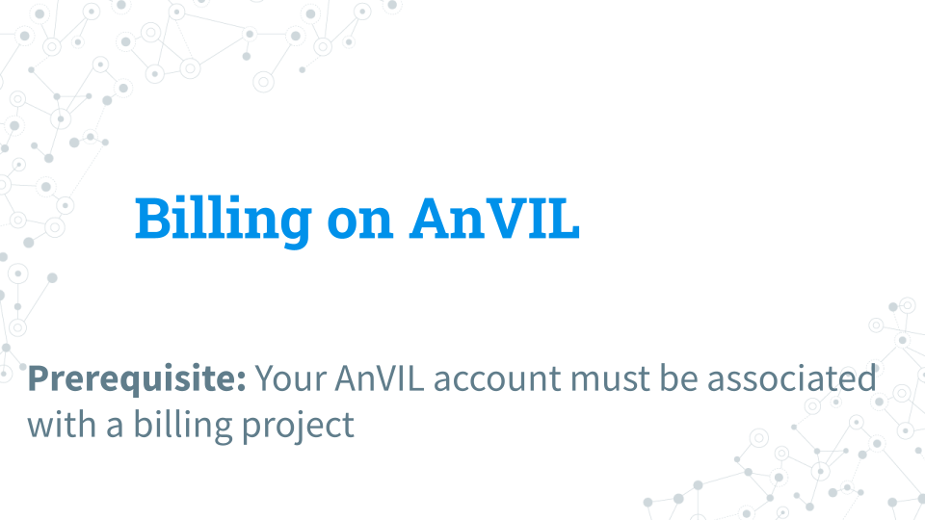

AnVIL will charge you for computing costs; as of the writing of this guide, the cost for running RStudio with the default settings is $0.06 per hour. RStudio will also cost $0.01 per hour while paused and not in use. Additionally, the persistent storage the environment comes with (50GB) costs $2.00 per month if not deleted.

To minimize costs, we ask students to delete their RStudio Environment and persistent disk at the end of every session. While you can also reduce the amount of CPUs and memory allotted per session this will also slow down your computation.

We will not go over setting up a Google billing account which you will need to setting up a billing project on AnVIL. For assistance with setting up your billing account we suggest refering to the Terra (the platform on which AnVIL runs) [guide to billing](https://support.terra.bio/hc/en-us/articles/360048632271-Terra-costs-and-billing-GCP-details) and speaking with your institution’s information technology and finance departments.

#### 5.3.0.1 Purpose

We will learn about the billing structure of AnVIL and how to attach users to billing projects. We will then cover how to create groups on AnVIL which you may find helpful in organizing billing.

#### 5.3.0.2 Learning Objectives

1. Distinguish between a billing account and a billing project
2. Understand how billing projects are connected to workspaces
3. Add users to a billing project
4. Learn how to create groups that can be used to control users’ access

### 5.3.1 What is a billing project?

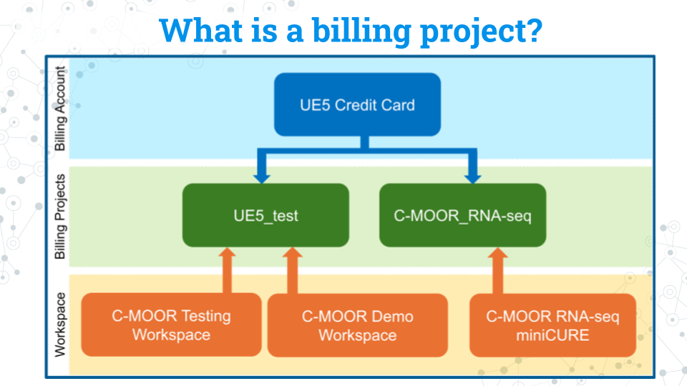

A billing project is used to connect a workspace - where students will be executing code - to a billing account, which is where your actual payment information is stored. As you can see in the above diagram, a billing account can have multiple billing projects, and each billing project can be used by multiple workspaces.

We suggest each student uses their own workspace and attaching all those workspaces to a billing project for the class. Currently, AnVIL only allow you to monitor costs from billing projects, not workspaces. But having different billing projects shown above for each class can help you learn how much computational resources reach class is using.

### 5.3.2 Adding students to a billing account

Follow the written steps below or refer to the [slides](https://docs.google.com/presentation/d/1yyH3DZb8Et19galJhNPiUnCevrFRC1acvMG2PB52FCo/edit?usp=sharing) or video guide.

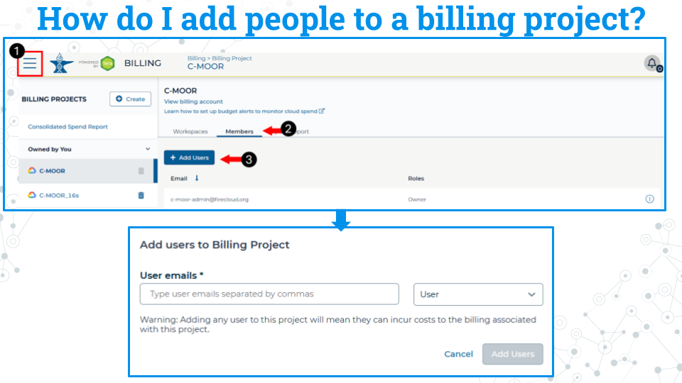

1. Access billing by clicking on the hamburger icon in the top left corner of the window, click on your name, and select billing. That brings you to your billing projects page.
2. On the billing project you’d like to use, click on the Members tab.
3. Click Add users. A new window will open. You are then able to add students to the billing project with the same email they used to sign up for their AnVIL account.

### 5.3.3 Using groups to manage classes

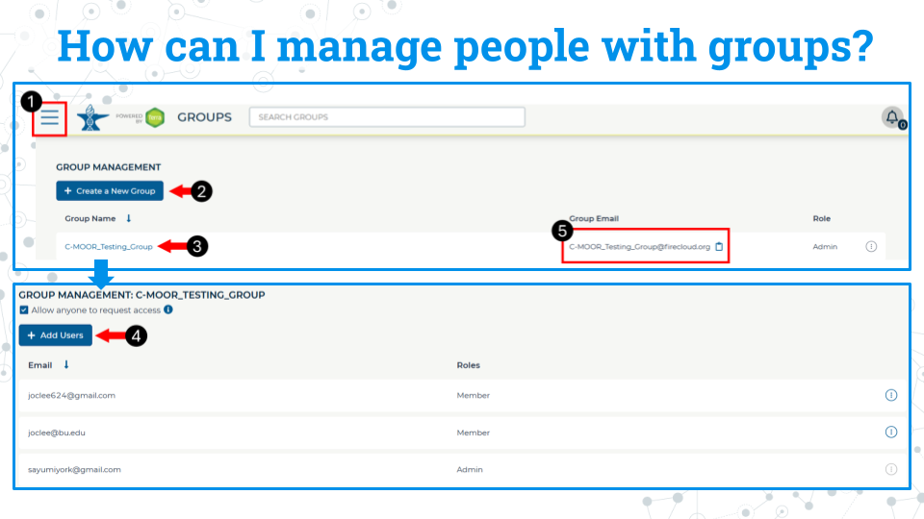

If you have a lot of students and classes, you may find it helpful to organize your students with groups. Everyone in the group is controlled by a single email address.

1. Access billing by clicking on the hamburger icon in the top left corner of the window, click on your name, and select groups. This will take you to this groups page.
2. Click Create New group. You will be prompted to give your group a unique name.
3. Click on the name of the newly created group to enter it.
4. Click add users. Add users to the group using the same email they used to sign up for AnVIL.
5. You can use the group email created for the group seen on the group management page to manage everyone in that group. For example, you can add everyone in the group to a billing project by adding this group email to the billing project.

### 5.3.4 Preventing runaway costs

Our team at C-MOOR is still piloting our curriculum on AnVIL. As such, we don’t have much information on the approximate cost per student. We hope to provide this data in the future.

The best way to conserve costs is to make sure that students close out their session on AnVIL properly, including the deletion of the persistent disk after they are done working. AnVIL will continue to bill the billing project even if the environment is not in active use.

For more information on how to control computing charges, please see the Terra guide: [How to cut off GCP charges](https://support.terra.bio/hc/en-us/articles/360042023952-Runaway-costs-How-to-cut-off-GCP-charges).

## 5.4 Running a module on AnVIL

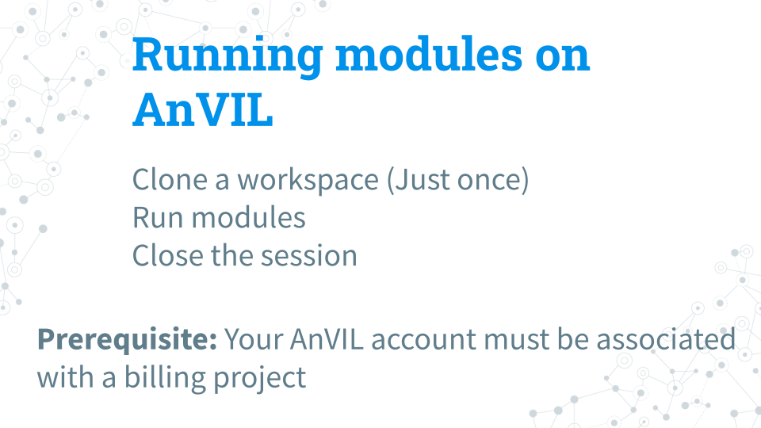

#### 5.4.0.1 Purpose

In this section we will go over how to run C-MOOR modules on AnVIL. First we will need to clone the workspace that correlates to the research project we want to do (RNA-seq or 16S). We will only need to do this step once. Then we will go over how to create an RStudio environment in that workspace to run the module and properly end a session on AnVIL to prevent runaway costs.

#### 5.4.0.2 Learning Objectives

1. Clone a public workspace for the research project you want to do (RNA-seq or 16S)
2. Launch a module through the cloned workspace
3. Close out a session on AnVIL properly to prevent runaway costs

### 5.4.1 What is a workspace?

The workspace is the heart of AnVIL. Here are some key points about workspaces:

* Every workspace comes with its own Google Bucket (our cloud storage). Your bucket will be empty.
* Every workspace has its own billing project. Students who are not yet associated with a billing project will not be able to compute on their workspace.
* We can control access levels of users and set them either as owners, writers, or readers. Students will be writers with compute access.

### 5.4.2 Clone a workspace on AnVIL

**We only have to do this once.**

Follow the written steps below or refer to the [slides](https://docs.google.com/presentation/d/11wb3b7i9SwrDX_WO3mWNAycd2mbY4Moy8SuT0X3XvXo/edit?usp=sharing) or video guide.

1. While logged into AnVIL, using the hamburger icon in the top left corner of the screen, navigate to the workspaces page
2. Select the public tab
3. Search for the desired workspace. Your instructor will tell you which workspace to look for (miniCURE-RNA-seq or miniCURE-16S-Human_Gut).
4. Click on the more options icon on the right side of the desired workspace and click clone
5. Give the cloned workspace a unique name, such as by adding your initials or last name. All workspaces must have unique names; if someone has already taken the workspace name you initially wanted, please try a different name.
6. Confirm the billing project is the one your instructor has chosen.
7. The rest of the options should be left as is. Clone the workspace. It may take a few minutes to clone.

**You only have to clone the workspace once. From now on, use your cloned workspace.** After you clone the workspace you will automatically be directed to it. For all other times, your workspaces can be found using the hamburger icon in the top left.

### 5.4.3 Running modules on AnVIL

#### 5.4.3.1 Starting a module on AnVIL

When you open the workspace, you will be on the dashboard tab by default. The dashboard contains the instructions on how to use the workspace, links to C-MOOR websites, and the startup script.

1. **Copy the startup script**. Make sure there are no spaces before or after what you copy. This script is held in the original workspace everyone cloned. It does not have to be in your own workspace for it to work.
2. Click on the Environment Configuration button (cloud with thunderbolt)

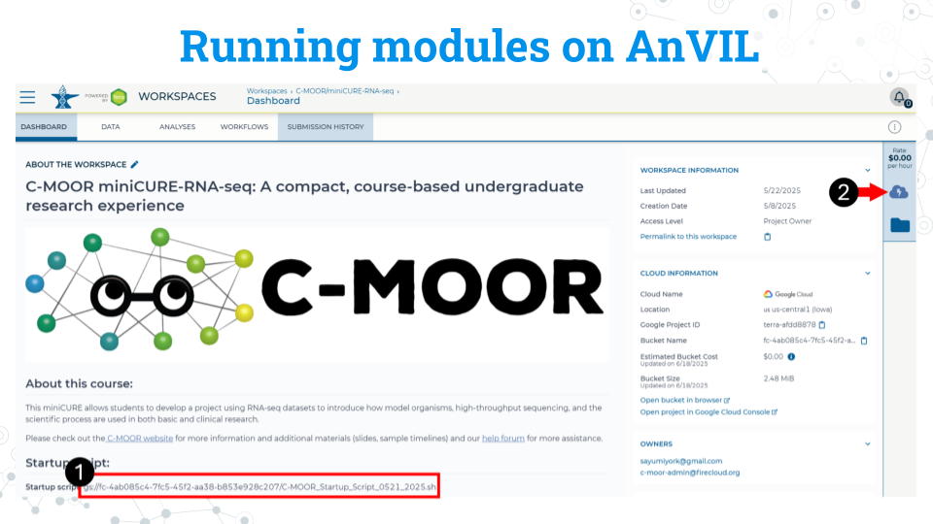

1. In the RStudio section, click Settings
2. In application configuration, select Legacy RStudio (R 4.4.1, Bioconductor 3.19, Python 3.10.12).
3. In the **startup script field, paste the startup script**
4. Scroll to the bottom of the window and click “Create”.

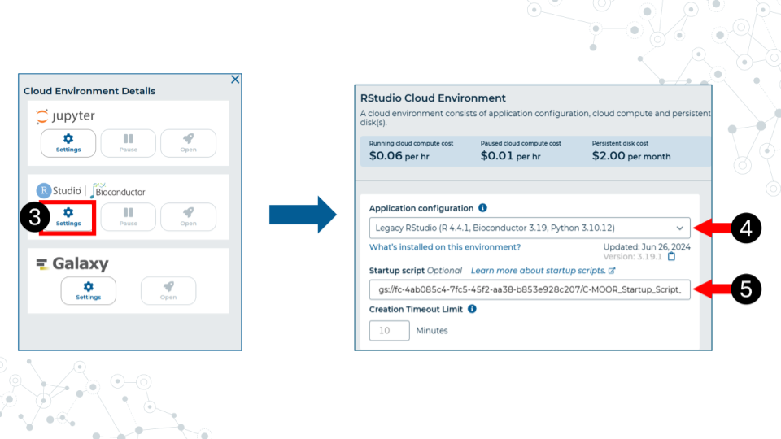

It will take some time for the RStudio Environment to be created. You can keep track of the status of the environment based on the colored dot next to the RStudio icon. The dot will turn green when the environment is ready. While it is loading (blue), you cannot interact with it.

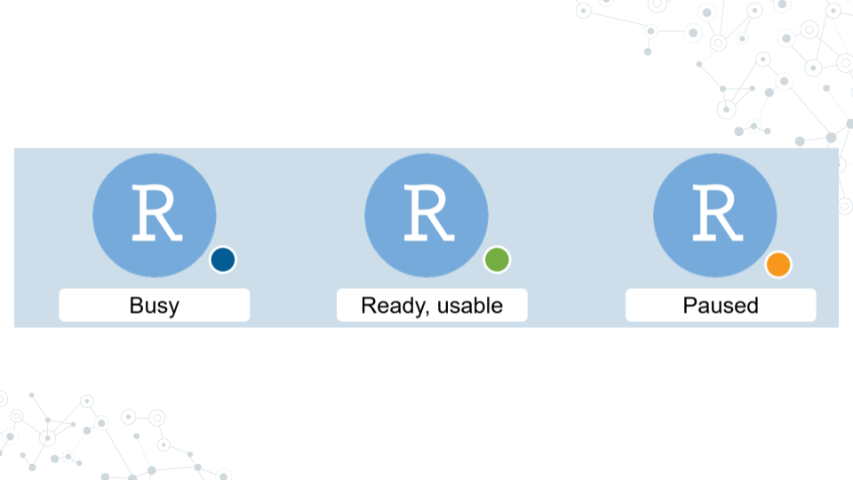

1. When the environment is ready, use the Open RStudio button that will pop up. You can also access RStudio through the Analyses tab. If you hold down Ctrl as you click, you can open RStudio in a new window.

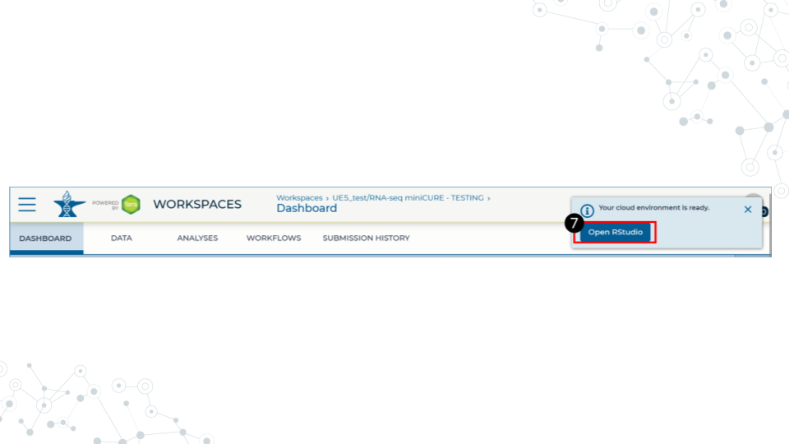

1. Use the file explorer in RStudio to navigate to your module of choice. From the folder called cure-rnaseq, go to tutorials, and then the folder of the module you want.

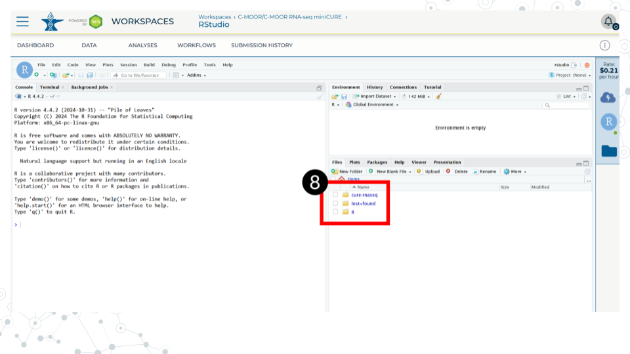

1. In the module’s directory, open the .Rmd file by double clicking its name.

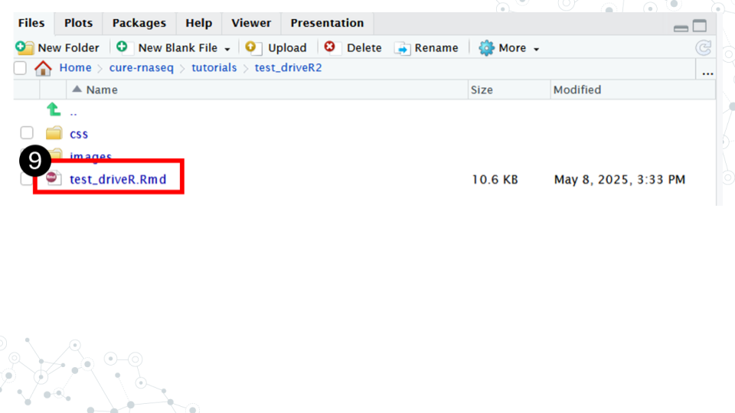

1. Click Run Document in the open .Rmd file

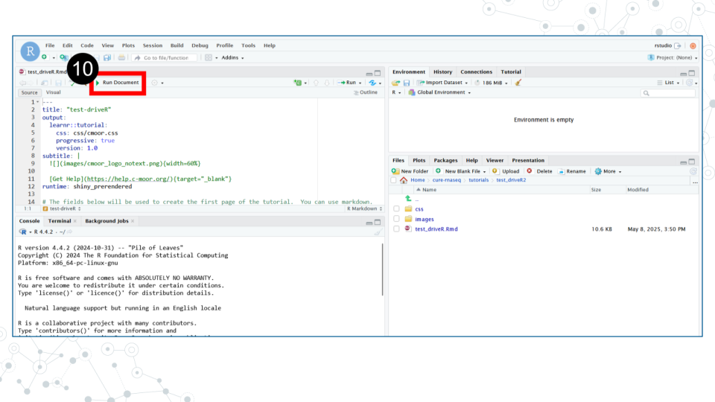

**When you are finished, make sure you close out your session properly to prevent runaway costs!**.

### 5.4.4 Closing out a session on AnVIL

1. On the right side of the screen, click the Cloud Environment button. This is the Cloud with the lighting symbol.
2. Under the RStudio section, click settings.
3. Scroll to the bottom of the new window and click delete environment.
4. Check **Delete everything, including the persistent disk or your instructor’s billing account will incur costs for storage**.

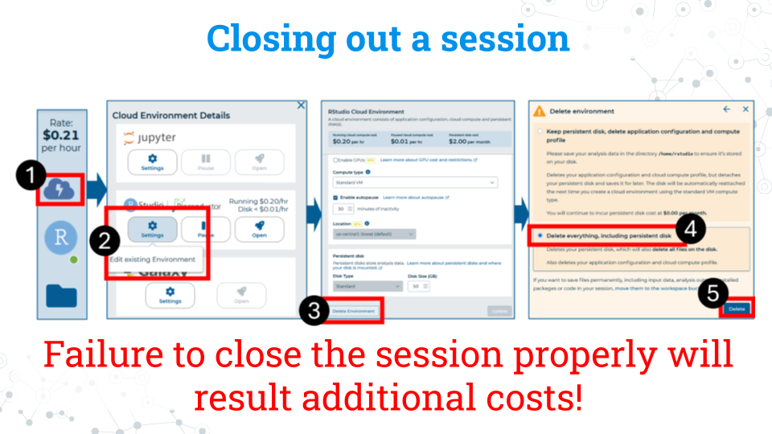

# 6 Scientific Posters

In this section we will go over how to create a scientific poster. We chose a poster as our final deliverable in C-MOOR because they:

* **Facilitate participation in research symposiums**: Students can use their poster to apply to present at research symposiums or conferences with minimal additional effort beyond what they do in class. If your institution does not have a research day, consider starting one using these posters as a foundation as we did at Clovis Community College! Your school’s library is another great point of contact in getting a poster session or research day set up. Some of the events students have participated in using their C-MOOR projects include:
  + The Clovis Community College Research Day
  + The Notre Dame of Maryland University Research Day
  + The GRADS-4C Conference (2025)



* **Serve as a physical representation of student achievement**: If printed, once finished with the class, students can choose to take their poster with them or leave it with the class to be hung up around the classroom or the hallways. This gives their research project more visibility, serves as an advertisement for other students who might be interested in taking the class, and showcases what students have accomplished.
* **Can easily be shared digitally**: A presentation can’t be repeated twice without a recording, and each recording can take up a lot of digital storage. A poster on the other hand, is a great compressed product that can be posted on a student’s (or the institution’s) social media and help get their work seen by others. Posters are even small enough that they can be attached to an email and sent to prospective supervisors and collaborators interested in a quick summary of their work. See our [Look at This!](https://help.c-moor.org/c/look-at-this/) category on the C-MOOR Academy Discussion Forum to see all the posters students have created and shared so far!
* **Posters can be used to measure student achievement and understanding**: We have previously used these posters to evaluate student learning, even years after students have left the classroom. Check out our [poster on posters!](https://drive.google.com/file/d/1kK6FBBLbHiAAsTUgxwzHRlK1qCo__eCy/view?usp=sharing)

## 6.1 Lecture - Scientific Posters

*Estimated time: —*



[Scientific Posters](https://docs.google.com/presentation/d/1-orSi8DpN22hMt9-6p_rHZnte1YXXLe-a132HDSyd0U/edit?usp=sharing)

## 6.2 Activity - Scientific Posters

### 6.2.1 Activity

*Estimated time: —*

#### 6.2.1.1 Instructions

1. Review [**Presentations Guidelines for Posters**](https://ur.umbc.edu/urcad/resources/posters-guidelines)
2. Skim three posters from among the following (must be Biology if from UMBC Posters)

* [**Look at This! Category on the Academy Discussion Forum**](https://help.c-moor.org/c/look-at-this/8)
* [**UMBC Biology Posters**](https://ur.umbc.edu/poster-presentation-examples)
* [**The example PacBio Poster**](https://www.pacb.com/wp-content/uploads/PAG-Portik.pdf)

1. Pick one poster and address the following points.

* **Notice** – What about this poster most interests you?
* **Wonder** – Two or three questions you would ask the authors.
* **Support** – Two or three suggestions on how the poster could be improved.

1. Post your answers by replying to the “Project Work: Scientific Posters” topic in the Discussion Forum

### 6.2.2 Grading Criteria

* Submit URL to your reply on Canvas.

### 6.2.3 Footnotes

**Contributions and Affiliations**

* Valeriya Gaysinskaya, Johns Hopkins University
* Frederick Tan, Johns Hopkins University

Last Revised: February 2025

## 6.3 Making Group Poster

### 6.3.1 Preparing to make a poster

An important part of scientific research is presenting your findings. Poster is a powerful visual way to communicate new and exciting findings, share ideas and get feedback. No wonder Poster sessions are an integral part of any conference or symposium. Throughout research project work, students will work with their groups to put together a scientific research poster.

### 6.3.2 Part 1 - Choose a Template

*Estimated time: 5 minutes*

1. With your group, open a suggested [poster template](https://docs.google.com/presentation/d/1chz02nzYklAEjOtHrPsJZccGy1sFUZvqdlfcUyfj3I4/edit?usp=sharing) to use for your poster.
2. Discuss with your group how you will divide up the work and exchange important information (e.g. phone numbers, email). Consider the following sections:

* Abstract/Introduction
* Methods
* Results
* Conclusions/Discussion
* References
* Acknowledgments

Notice these posters are sized at 36 x 42 inches, but there are many other commonly used sizes. Refer to your instructor on what poster size to use; not every poster will fit every stand when printed (if applicable). Notice that the posters in this slidedeck come in two-column, three-column, and mixed formats. Think about your figures and tables and select a format that makes the most sense for them. There are also some example posters in the last two slides that we will use to examine the anatomy of a research poster further in the next part.

### 6.3.3 Part 2 - Make an Academic Research Poster

*Estimated time: —*

1. Complete the following components of your research poster with your group. You might not do them in this order, but these are the components you are being graded on. For more details on each of these sections and their role in a scientific paper, see the Scientific Literature Lab.

#### 6.3.3.1 The header: title, authors, and affiliations



Since you completed this work as a team of scientists, all of your team members are considered authors. List your team members in alphabetical order. The author’s affiliation is the university, college, research institution or company that the work was conducted at.

* An example affiliation for Clovis Community College would be: “Department of Biology, Clovis Community College, California, United States.”
* If multiple institutions exist, you will need to use superscript to denote who has what affiliation (see the example poster).

We will include the C-MOOR logo, the logo of your institution(s), and the most immediately relevant funding source (if applicable) in the header.

**Check the header of your poster:**

* ☐  All authors are listed
* ☐  All authors’ home institutions are referenced
* ☐  The title of the poster is focused on your specific project topic (ex. genes, variables, model organism)

The title of the poster describes the main result of your research The title of the poster does not overstate the findings or significance of your research

* ☐  The C-MOOR logo is included
* ☐  The logos of your institutions are included

#### 6.3.3.2 Abstract

C-MOOR Abstract examples:

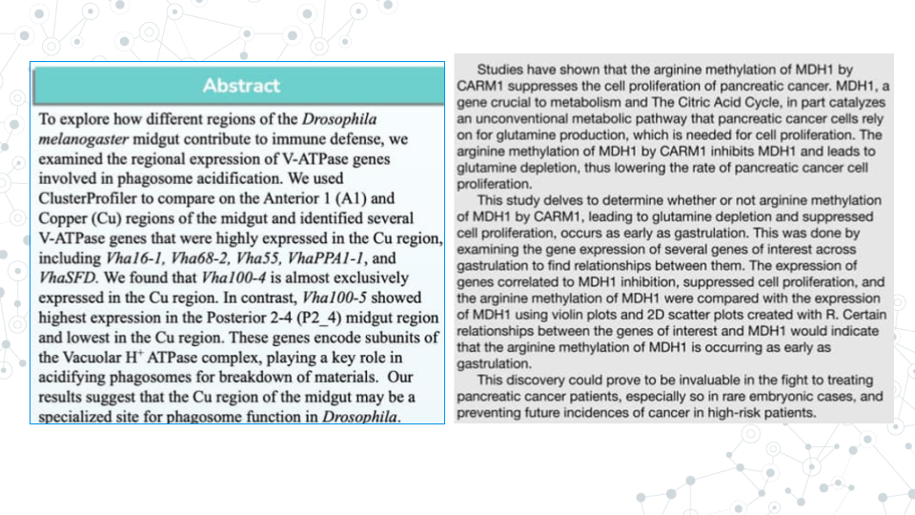

PacBio’s published abstract on ‘Genome-resolved metagenome assembly of human oral microbiome using highly accurate long-read sequencing’.

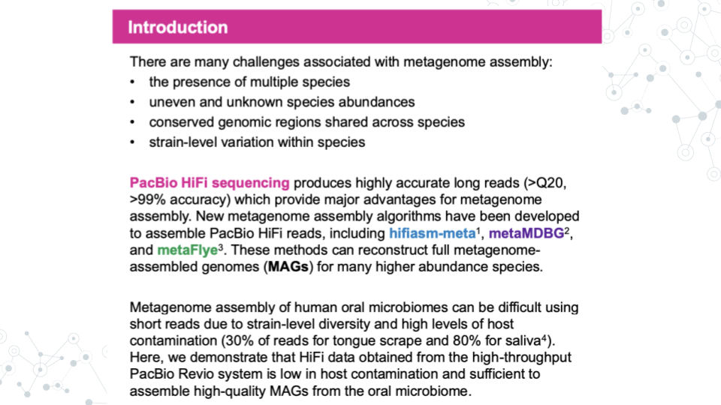

An abstract is a concise summary of your work. An effective abstract will inform the reader of the relevant background to the research, scientific hypothesis being tested, the purpose of the study, the main methods, and the most important results and conclusions.

Abstract can be difficult to write because it combines all research pieces and requires effective and consice communication of those sections. Many scientists choose to write the abstract last, after they fully understand the conclusions and implications of their work. Identify your scientific question, your hypothesis, and the knowledge gap (the unknown your research is addressing) first. Then brainstorm what you will need to tell your readers in terms of context and background.

**Your abstract should do the following:**

1. Include relevant background information such as:

- A problem or question at hand   
- Model organism  
- The gene of interest and its function   
- The relevant phenotypes (e.g. disease-state)   
- The known connection between genotype and phenotype  
- Relevant biological processes

1. Clearly state hypothesis, aims, and/or objectives of the research.

- e.g. Our hypothesis is that the healthy gut microbiome has more microbial diversity than the gut of an individual with a celiac disease.`  
- e.g. We hypothesize that maternal antibiotic treatment correlates with higher antibicrobial resistance in infant microbiome.`

1. Summarize or briefly mention methodology you used in your research.

- e.g. Using Galaxy we analyzed the genomic diversity of the gut microbiome and compared fecal samples between individuals with Celiac Disease (CD) and a control group on a healthy diet without CD.`  
- e.g. We analyzed a publically available dataset comparing RNA-seq gene expression between the left and right eye in DESeq2.`

1. Summarize the main results of your study, and how they may relate to the hypothesis.

- e.g. We found that gene X was differentially abundant between the eye and all other tissues, suggesting gene X plays an important role in the eye. This may be important for learning more about eye development and X condition.`   
- e.g. We found an association between age and the presence of Y bacteria, which supports our hypothesis that Y bacteria is involved in the disease state`

#### 6.3.3.3 Introduction

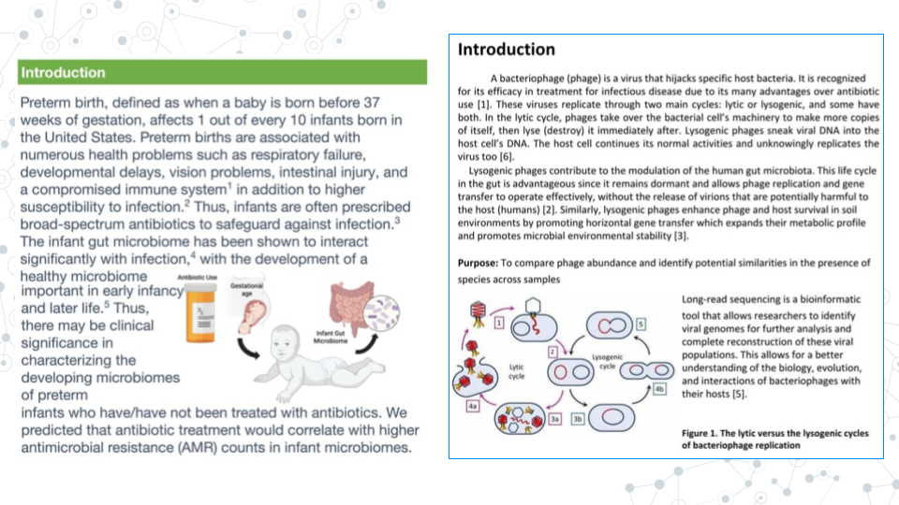

Introductions typically appears immediately after the Abstract section and contains background information. Sometimes, an Introduction section can be used instead of the Abstract section, in which case, the Introduction will contain both, abstract information plus additional background information. An Introduction typically contains the relevant information and context needed to understand the study and the study’s hypothesis/aims/objectives and does not include the methodology, results, or takeaways from the study.

#### 6.3.3.4 Materials and Methods

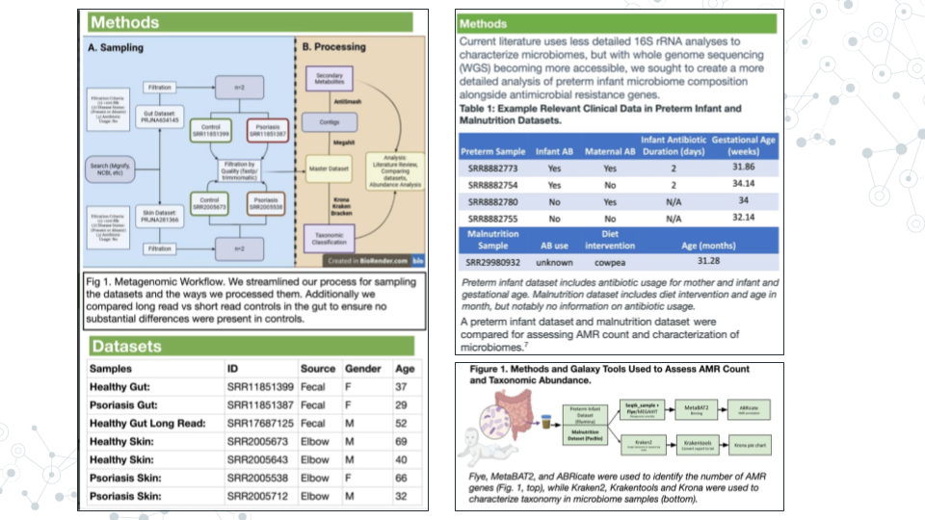

The materials and methods section will detail your analysis of the data. Don’t provide any of your results, just the methods. If you did not generate the data yourself from raw samples, you will simply cite the paper that made them instead of detailing their construction. We will also need to list any programs we used and provide credit to their creators.

Some other things you might include would be what type of analysis you decided to do (which parts of the body parts you analyzed, sets of genes, what p-value you used, etc.).

#### 6.3.3.5 Results

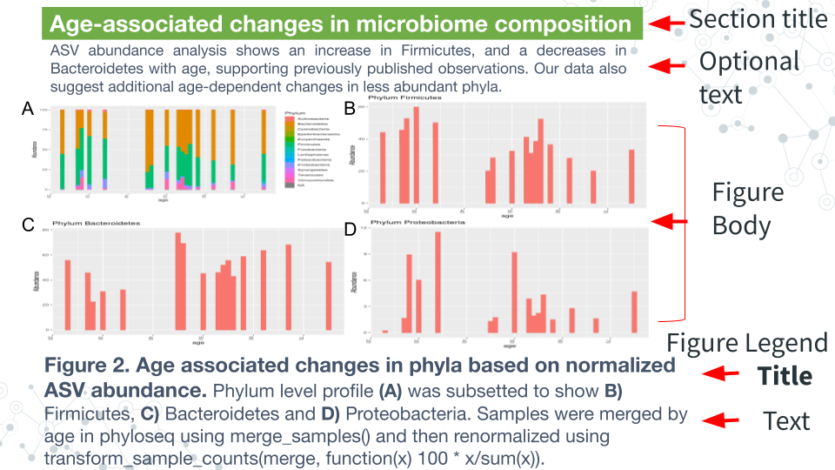

The Results section is where you will detail your data primarily through **figures and tables**, though sometimes written text is included. Begin by creating your tables and figures.

**Figure body**:

* Has high resolution images, well spaced and labeled parts and text.
* Place the figures and tables in order of how you want to present them and name them such as **Figure 1, Figure 2, Table 1, Table 2, etc**.

**Figure Legend**:

* Figures have their legends *underneath* them. Tables may have their legends also *above* them.
* The legend should be in a smaller font than the main text on the poster.
* A legend should includes a **figure title**, which is a declarative statement that summarizes findings.
* A legend also includes **figure text** which a) identifies (and can briefly describe parts), b) includes brief description of of methods necessary to understand figure and c) should include relevant statistics (stats).

**Optional components**

* Figures and Tables can have additional (optional) text. E.g.an optional text can describe the findings of the figure upfront to engage.
* A **Section Title/Header** which summarizes section or figure in a manner that is broader than figure legend title - an attention grabber.
* Bullet pointed text that summarizes the main findings of the figures/tables.

#### 6.3.3.6 Conclusions/Discussion



The discussion section of the paper is your chance to analyze and interpret your results. The discussion section generally addresses the following:

* What do your results mean?
* How do they fit into the bigger picture?
* If any experiments did not give expected results, hypothesize why that might have been the case and propose alternate experiments that could confirm or clarify your results.
* Include at least one sentence of future work that you would do if you had more time or what students in upcoming semesters could do to continue to answer your questions.

#### 6.3.3.7 References



All the references that you cite on your poster must be present in a References section including the following sections: Introduction, Methods, and Discussion. To save space on our posters, we will number our references (ex. 1-5) and use the numbers as citations throughout the text of your poster. You may have a lot of references; it is okay to put them in tiny text if you have to in order to make them fit.

There are many different ways to format the reference section. We will make ours in alphabetical order by the first author’s last name. All of your sources must be scientific journals and should use the following format:

Authors (year) “Title.” Journal Name, vol. #, page #s, DOI

Online article that is also in print:

Haussecker D., Huang Y., Lau A., Parameswaran P., Fire A. Z. and M. A. Kay (2010) “Human tRNA-derived small RNAs in the global regulation of RNA silencing.” RNA, Vol. 16, page 637-695, <doi:10.1261/rna.2000810>

Online article only:

Marianes, A. and A. C. Spradling (2013) “Physiological and stem cell compartmentalization within the Drosophila midgut.” eLife, <doi:10.7554/eLife.00886>

#### 6.3.3.8 Acknowledgements



The acknowledgements section is where you give thanks to the people, organizations, and institutions that have supported you in your research. If relevant, include the grant ID # of your funding source. Institutions and organizations that have contributed to your research - but you do not belong to - can be thanked here.

### 6.3.4 Part 3 - Proofread and Add Final Touches

*Estimated time: 30 min to an hour*

1. Each group member should re-read the poster from beginning to end and fix any typos or grammatical errors.
2. Check the alignment of figures, text boxes, titles, etc.
3. Add some finishing touches. You can play with the color, the font, add additional images if it’s relevant.

### 6.3.5 Part 4 - Canvas Discussion

*Estimated time: 30 min*

You will turn in your poster to be graded as a group in a Canvas Assignment and post it to a Canvas Discussion to be viewed by the class.

1. Convert your poster to a pdf.
2. Have one member of your group turn in the pdf of your poster to the Graded Canvas Assignment. This assignment is already set up so that if one group member turns it in, it will show as submitted for all students in the group. This is where your instructor will grade you poster as a group.
3. Have one member of your group post a pdf of your poster in the Canvas C-MOOR Poster Discussion.
   1. With your poster, introduce your group members and copy and paste your abstract into the post.
   2. Insert your pdf into the post and edit the link so that it automatically shows the inline preview. This will make it easier for students to view your poster.
4. As an individual, read through the other posters from different groups.
5. Post comments

### 6.3.6 Grading Criteria

Your instructor will provide for you a rubric specific to your class. Refer to the rubric as your build your poster to make sure you have all the neccessary components.

### 6.3.7 Footnotes

#### 6.3.7.1 Resources

* [Google Doc]
* [Generic rubric](https://docs.google.com/document/d/13eB1fwHEB1I00JHBUQLZIJsi-iQZYaWaXThPqCTU17g/edit?usp=sharing)

#### 6.3.7.2 Contributions and Affiliations

* Stephanie R. Coffman, Clovis Community College
* Valeriya Gaysinskaya, Johns Hopkins University
* Frederick Tan, Johns Hopkins University
* Sayumi York, Notre Dame of Maryland University

Last Revised: July 2025

## 6.4 Activity - Share Your Poster

### 6.4.1 Introduction

It’s almost time! Prepare for your final presentation by thinking about how to describe the great work that you’ve done this semester in both written and oral form. Assume that your audience has a basic scientific background but does not know a lot about your particular field. Provide enough context to give your listener a reason to care about your project and each of the results you will describe. You have five minutes to get your story across so have a plan and practice.

#### 6.4.1.1 Activity 1 – Share Your Poster

*Estimated time: 20 min*

#### 6.4.1.2 Instructions

1. Download your poster as a .png file

* <https://drive.google.com/drive/folders/1y_GCJl7VIYTS_5y7057u2s58ZCdm_PxM>

1. (One person on behalf of the group) Create a New Topic on the Discussion Forum with the title of your poster as the topic title and your .png file as the contents in either the
2. Look at This! category if every member of your group is ok sharing your work publicly <https://help.c-moor.org/c/look-at-this/8>
3. JHU 2025 Spring category if you need to keep your work private <https://help.c-moor.org/c/jhu-2025-spring/46>
4. (Each person in the group) Reply to your topic using your own words with the following two bolded sections using the following template

|  |
| --- |
| **What I Did** |
|  |
| **How You Can Help** |
|  |

#### 6.4.1.3 Questions

| 1. Provide URL of your Discussion Forum post |
| --- |
|  |

### 6.4.2 Activity 2 – Present Your Poster

*Estimated time: 40 min*

#### 6.4.2.1 Instructions

1. Create a plan for a 5 min presentation taking into consideration
2. Who will speak when
3. What each person will cover
4. Practice your presentation
5. In your group
6. To the class

#### 6.4.2.2 Questions

| Create a bullet point outline of who will speak what when: |
| --- |
| Overview (question, background, hypothesis) |
| Approach (dataset, general methods) |
| Results (detailed methods, notable results) |
| Conclusions (summary, next steps) |

### 6.4.3 Grading Criteria

* Download as Microsoft Word (.docx) and upload on Canvas

### 6.4.4 Footnotes

**Resources**

* [Google Doc]

**Contributions and Affiliations**

* Valeriya Gaysinskaya, Johns Hopkins University
* Frederick Tan, Johns Hopkins University

Last Revised: April 2025

# 7 Professional Development

Now that you’ve finished your C-MOOR project, how do you close out your research experience or take it further? In this section we’ll explore how to publicize and use your experience to help build your professional career.

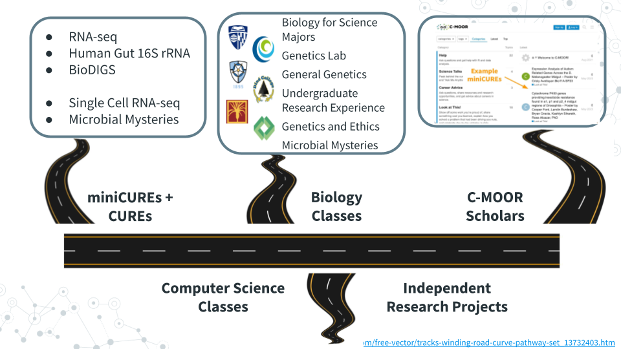

## 7.1 Lecture - Next Steps

*Estimated time: —*



[Slides: Next Steps](https://docs.google.com/presentation/d/1PMvZ19kSTK2ghdgLNFRS_t5p8R_GKFNbExPRxMsE1Ns/edit?usp=sharing)

## 7.2 Activity - Next Steps

### 7.2.1 Introduction

Congratulations on making it to the end of Microbial Mysteries! Take a moment and reflect on all that you’ve accomplished during this semester, especially those of you who reported in the Welcome Poll “No experience” with Microbiology, Galaxy, and Scientific Research. While the “Grad Student Motivation Level” PHD Comics spans years, it likely reflects the ups and downs as you developed and explored your hypothesis, including the thrill of presenting your work to people in our mini-symposium. The feedback has been great with faculty impressed at what you’ve accomplished, the depth that you understand your projects, and even one scientist who does metagenomics research reporting that they learned a new trick or two!

We’ll wrap up today with several next steps including completing feedback to improve the next offering of this course , researching opportunities to do more science, exploring communities where scientists openly share insights, and optionally sharing more work.

### 7.2.2 Activity 1 – Complete Feedback

*Estimated time: 15 min*

#### 7.2.2.1 Instructions

Help us improve this course as we work to grow enrollment to accommodate 32 to 64 students, incorporate graduate TAs and undergraduate course assistants and tutors, and promote more computational training and research opportunities throughout departmental courses <https://forms.gle/XkqiMERHc2PETmy4A>

### 7.2.3 Activity 2 – Research Opportunities

| 1. Find one LAB at YOUR INSTITUTION that you would work in and explain why. |
| --- |
| Your text here: |

| 2. REU – Which NSF Research Experiences for Undergraduates program would you attend and why? |
| --- |
| a. Overview – <https://www.nsf.gov/funding/initiatives/reu/students> |
| b. Search – <https://www.nsf.gov/funding/initiatives/reu/search> |
| - Consider filtering by Research Area (e.g. Biology) |
| Your text here: |

### 7.2.4 Activity 3 – Explore Communities

*Estimated time: 15 min*

#### 7.2.4.1 Instructions

Spend a little bit of time browsing communities that discuss genomics, data analysis, and more. Paste the URLs for a couple of posts that you find interesting with a brief comment.

#### 7.2.4.2 Questions

1. Specialized Communities
2. SEQanswers: the next-generation sequencing community

* <https://www.seqanswers.com>

1. Biostars: bioinformatics explained

* <https://www.biostars.org>

| Post URL of interest for Specialized Communities and your comments here: |
| --- |
|  |

1. General Communities
2. Reddit: The heart of the internet

* <https://www.reddit.com/r/metagenomics>

1. Twitter/X: It’s what’s happening

* <https://x.com/search?q=%23metagenomics>

1. Bluesky: Social media as it should be

* <https://bsky.app/search?q=metagenomics>

| Post URL of interest for General Communities and your comments here: |
| --- |
|  |

### 7.2.5 (Optional) Activity 4 – Share Work

*Estimated time: 15 min*

#### 7.2.5.1 Instructions

1. Upload photos – Especially photo of your group standing in front of your poster

* <https://drive.google.com/drive/folders/1y_GCJl7VIYTS_5y7057u2s58ZCdm_PxM>

1. Publicly share poster – If every member of your group is ok sharing your work publicly

* <https://help.c-moor.org/c/look-at-this/8>

### 7.2.6 Grading Criteria

* Download as Microsoft Word (.docx) and upload on Canvas

### 7.2.7 Footnotes

**Resources**

* Google Doc

**Contributions and Affiliations**

* Valeriya Gaysinskaya, Johns Hopkins University
* Frederick Tan, Johns Hopkins University

## 7.3 Science Talks

Science Talks feature a guest lecturer to showcase their research work, share their scientific journety and engage in Q and A with the students. It is a one of a kind opportunity for students to engage with a scientific scholar and/or expert from across departments, fields, and career stages and explore, broaden or narrow students’ scientific interests.

The two invited speakers for the Microbial Mysteries CURE Spring 2025 at the JHU were:

1. Dr. Karina Gutiérrez-García
2. Dr. Leah Guthrie

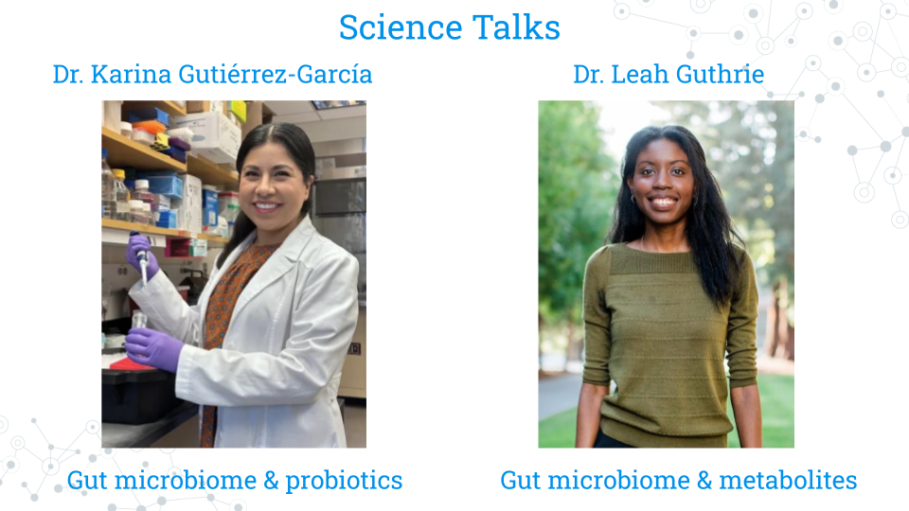

For each speaker, students were asked to prepare by completing the Science Talks Activities.

### 7.3.1 Science Talks - Activity 1

*Estimated time: 50 min*

1. Read/Browse the following information about **Dr. Karina Gutiérrez-García**
2. Postdoc Spotlight <carnegiescience.edu/news/postdoc-spotlight-karina-gutierrez-garcia>
3. “Home sweet home” perspective on study of fruit fly gut microbiome <pubmed.gov/39637006>
4. Abstract for “A conserved bacterial genetic basis for commensal-host specificity” <pubmed.gov/39636981>
5. Abstract for “Gut microbiomes of cycad-feeding insects tolerant to β-methylamino-L-alanine (BMAA) are rich in siderophore biosynthesis <pubmed.gov/37993724>
6. Post three questions to the speaker in the Discussion Forum at <https://help.c-moor.org/t/469>.
7. Science – What scientific question do you have about Speaker’s research, ranging from basic background questions to possible next steps?
8. Method – What methods would you like the Speaker insight on, whether computational, genomics, or other exciting technologies?
9. Career – What advice would you ask the Speaker for regarding how to get started, finding a mentor, etc.?

### 7.3.2 Science Talks - Activity 2

*Estimated time: 50 min*

1. Read/Browse the following information about **Dr. Leah Guthrie**
2. Faculty focus <qb3.berkeley.edu/news/faculty-focus-leah-guthrie>
3. Abstract for “Impact of a 7-day homogeneous diet on interpersonal variation in human gut microbiomes and metabolomes” <pubmed.gov/35643079>
4. Abstract for “Human microbiome signatures of differential colorectal cancer drug metabolism” <pubmed.gov/29104759>
5. Post three questions to the speaker in the Discussion Forum at [https://help.c-moor.org/t/469](https://help.c-moor.org/t/498).
6. Science – What scientific question do you have about Speaker’s research, ranging from basic background questions to possible next steps?
7. Method – What methods would you like the Speaker insight on, whether computational, genomics, or other exciting technologies?
8. Career – What advice would you ask the Speaker for regarding how to get started, finding a mentor, etc.?

## 7.4 Create your CV

*Estimated time: 10 min*

Everyone who completes a C-MOOR project can add their experience to their resume or CV! We advise you and your students to do this as soon as possible after the end of class while your research project is still on your mind.

#### 7.4.0.1 Resume or CV?

You may hear the terms resume and CV being used interchangeably. While both are drawn from the same information, they vary in brevity and focus.

A **resume** is a one-page (sometimes two-page) document of your experiences generally used for jobs outside of academia and research labs. It’s not uncommon for people to have more than one resume, as it’s best to tailor every resume to each specific role you’re applying to.

A **Curriculum Vitae (CV)** is an extensive document that can take as many pages as needed to list the entirety of your research and academic experience. It often includes sections that aren’t found in non-academic fields such as publications, conferences, and published papers.

Most positions will detail which they require from applicants and most colleges and universities will be able to help you build either at your library or career center. We suggest that current students and recent graduates interested add their C-MOOR research experience to either their classwork or projects section. Remember to acknowledge the contributions of your team members if applicable; this does not count against you in your applications! Here are some examples of how you might word your experiences; notice how they’re similar to an abstract in just one or two sentences:

* **An RNA-seq project:** Along with a partner, examined differential expression data of the *period (per)* gene along the *Drosophila melanogaster* midgut from a published dataset (Marianes & Spradling 2013) using DESeq2 and ClusterProfiler. We discovered an elevated expression of per in the anterior region of the midgut where the primary digestion and absorption of carbohydrates occur. Our results were presented as a research poster at the 2025 Kuntz Research Day symposium and have implications for using Drosophila as a model for the connection between the circadian rhythm and metabolic disorders.
* **A 16S project:** My group and I profiled the abundance of Archean ASVs in the gut microbiome from a published 16S study comparing the gut microbiota of people before, during, and after a standardized diet (Guthrie et al. 2022). As a part of this study, we created a PCoA and performed an alpha diversity analysis in phyloseq. Archean community members are often overlooked in microbiome studies; we found differential abundance in *Methanobacteria* between male and female participants regardless of diet and hypothesize this may be due to consumption of fiber reported by male subjects pre- and post-diet.
* **A WGS project**: Public data (SRA#######) from Robinson et al. (2021) was analyzed in Galaxy using Trimmomatic, Megahit, and Krona to determine the viral abundance in samples from tap water from various North American Lakes and make comparisons to lake depth. Viral abundance was correlated with geographic distance between samples; future studies could examine if this pattern persists in samples sourced from Europe and Oceana.

Your blurb is a strong blurb when:

* ☐   You credit the source of your data (Citation, SRA #, Project #)
* ☐   You describe why your research project matters
* ☐   You list some of the computational platforms or software you used

**Q: Will people think I am an expert in genomics and bioinformatics if I put my project on my resume/CV? I don’t want to look like a phony.**

A: As a current student or new graduate, you are not expected to have mastery over any scientific domain. What you are trying to show is you have taken an idea and brought it to completion, your ability to learn new concepts and skills, and your previous exposure to research. You can explain more about your role in the project in an interview.

**Q: Can I list things like R or Galaxy in my skills section?**

A: You can, however we suggest being explicit in your experience and add the level at which you feel comfortable with each respective platform. Are you R (Beginner) or R (Proficient)? Can you teach someone else how to do your project? Can you perform your project with novel data? How good are you at troubleshooting? This answer may seem contrary to the previous one, but remember that other people who are listing these platforms in their skills section includes computer/data scientists (majors) and bioinformaticians (majors), so people may assume mastery. Think about it the same way you would a foreign language. Spanish (Beginner) describes a different level of skill than ‘just’ Spanish.

# 8 C-MOOR Scholars

## 8.1 C-MOOR Scholars



C-MOOR Scholars are research clubs that function as an extension of the C-MOOR curriculum. You can explore techniques and concepts from modules you’ve yet to take to learn about different approaches we can use to explore different questions through genomics, connect with other scholars and mentors, and experience the climate of a research lab.

Fill out our [C-MOOR Scholars Interest Form](https://docs.google.com/forms/d/1GJDpfG28k2utCVVcRXQraE-1coLS_GCX83irUyio9KE/viewform?edit_requested=true) if interested, and meet some [C-MOOR Scholars at Clovis Community College](https://www.cloviscollege.edu/alumni-and-community/c-moor/c-moor-scholars.html)!

**What C-MOOR Scholars is**:

* A place to grow your skills
* A place to network
* A place to connect science with the greater community

**What C-MOOR Scholars is not**:

* A commitment to pursuing research as a career
* A graded class where we score work
* A drop-in drop-out popular science club

Less formal than a class, more formal than just a gathering of like-minded minds, C-MOOR Scholars provides structure for your growth as a scientist. We are actively looking to recruit new scholars for chapters at our established sites (CCC, JHU, & NDMU); speak with your instructor for more information or reach out to us at the [C-MOOR Academy Discussion Forum](help.c-moor.org) to hear about any remote opportunities we have.

### 8.1.1 C-MOOR Scholars links

Share your interests via C-MOOR Scholars Interest Form and learn how C-MOOR community can support you.

* <https://docs.google.com/forms/d/1GJDpfG28k2utCVVcRXQraE-1coLS_GCX83irUyio9KE/edit>

Meet the C-MOOR Scholars and learn how you can support them

* <https://www.cloviscollege.edu/alumni-and-community/c-moor/c-moor-scholars.html>

## 8.2 Pursue further research

Perhaps you’re interested in pursuing research beyond what C-MOOR currently provides. Maybe you’re more interested in wet lab work, or a specific model organism. We encourage you to try all sorts of different opportunities even if you feel totally comfortable working with C-MOOR so you can better understand what kind of roles suit you best. This section serves as a guide for some common jumping off points to find outside research opportunities.



### 8.2.1 Research opportunities at your institution

Many colleges and universities have research programs for their students or resources available to connect you to some. You can ask your instructor, adviser, or library for more information. Some popular programs include:

* **Undergraduate Research Opportunity Programs (UROP):** Which often provide a database or pipeline of research opportunities for students at the univeristy or from surrounding areas.
* **Research experiences for undergraduates (REU):** Similar to UROP, but generally open for a wider audience of students from outside the community. See the [NSF REU website](https://www.nsf.gov/funding/initiatives/reu) for more information.

Opportunities come and go and often follow the academic-year in terms of availability. If you can’t find something immediately, keep trying!

### 8.2.2 Find a research lab to join

You can choose to pursue additional research opportunities in what we consider the more traditional way: by reaching out to a professor or research scientist whose work you are interested in and asking if they might be willing to have you in their lab. As these opportunities are at the discretion of the lab leader they will vary widely in their scope, duration, and ability to provide financial support.

An email to a potential research lab should contain:

* ☐  An introduction about yourself (name, class year, institution, major)
* ☐  1-2 sentences about your previous experience in research
* ☐  1-2 sentences about why you’re interested in their lab specifically
* ☐  A polite, open ended request to work with them

Dear Professor Penguin,

My name is Student, and I am a junior at My University majoring in biology (or other). I read your chapter on the genetics yellow-eyed penguins in Penguins: Natural history and conservation, and then checked out your profile on the University website. My interests are broadly defined in environmental toxicology and I am interested in the work you are doing using eDNA and studies on the effects of plastic on developing penguin transcriptomes.

I previously completed a project as a part of an RNA-seq miniCURE and have some exposure to working with DESeq2, though I still have much to learn. My group and I profiled the gene expression of the genes XYZ in the Drosophila midugt and I presented our poster at our university’s research day poster session.

Thank you for your time and consideration in reading my email. Please let me know if you are currently available to mentor an undergraduate in your lab and if you would be willing to have me as a potential student. I hope to hear from you soon!

Don’t be surprised if it takes the researcher a while to get back to you or if they respond curtly. They likely get many requests and are very busy. Continue to reach out to labs and apply to programs; it is difficult to know when opportunities are available as funding fluctuates.

## 8.3 BioDIGS

This section is primarily geared toward instructors as students will be able to get access to the BioDIGS data through their local C-MOOR Scholars chapter.



**What is BioDIGS?**: [BioDIGS](biodigs.org) is a project from the Genomic Data Science Community Network (GDSCN), which aims to characterize the microbiome of soil throughout sites in the US while connecting scientists to research.

**What makes BioDIGS different?:** Soil is hypothesized to be the most diverse system on our planet, and BioDIGS is gathering sequence data and matching environmental data to elucidate the connection of soil microbes to abiotic variables and human health. Students at participating sites can take the entire project from soil sampling all the way through computational analysis. Curricula and more information on how to get a soil sampling kit are available on the BioDIGS website.

# 9 Online Community

The genomic data science community is a remarkably open community that continually strives to increase opportunitites and broaden access to the scientific enterprise (e.g. [GDSCN 2022](https://pubmed.gov/35858750)). There are many opportunities to interact online with scientists that share a common research question, career stage, or even favorite tool! Below is a sampling of some discussion forums that you may find useful:

* [help.c-moor.org](https://help.c-moor.org) for help with and example miniCUREs
* [help.galaxyproject.org](https://help.galaxyproject.org) for all things Galaxy
* [support.bioconductor.org](https://support.bioconductor.org) for all things R/Bioconductor
* [help.anvilproject.org](https://help.anvilproject.org) for interactions with the GDSCN BioDIGS consortium <https://biodigs.org/#home>









# References